Set up Column Selector with Search

1. Create a new String Document Property, called “SelectedColumns” (no value, or can be list of columns to start off with being selected, in the same format as 2.a below)
2. Create a new String Document Property, called “AvailableColumns”; the value will be the name of the columns that should be available to add to the data table, separated by a comma:
   1. BANK_ACCOUNT_COUNTRY_CODE,BANK_ACCOUNT_NUMBER,CURRENCY_CODE,IBAN,BANK_ACCOUNT_TYPE,PAYMENT_FACTOR_FLAG
3. Create a Text Area (title doesn’t matter) – this will be for the search bar / column selector to go in.
4. Create a second Text Area (title doesn’t matter) – this will be for the buttons “Add” and “Remove” to go in.
   1. Edit HTML
   2. Somewhere on the area, put this element:

<div id="myInputField">

<SpotfireControl id="60005ec7034d49d9beb0d2c1fe9a6647" />

</div>

* 1. Replace the SpotfireControl element with an “Input field” on the Document Property “SelectedColumns”. You can format this control to be very tiny so it isn’t noticed.

1. Create a new Data Table visualization (or you can use an existing one, this will be for columns to be added / removed…)
2. Enter these scripts (File - > Manage trust and scripts -> New -> IronPython); you skip scripts you will not use (widen / narrow columns, etc)
   1. SetSearchVisualization requires 2 parameters; textArea is the text area vis created in step 3. tableVis is the table created in step 5. 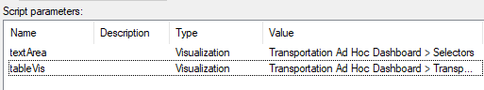
   2. The rest of these scripts require only 1 parameter – “tableVis”, which is the table created in step 5.



1. Where necessary, create buttons for the scripts. I usually put the buttons in the same HTML Text area created in step 4.